



adges UI components library

**Component ID Header - v1.0**

## Document Control

## Version History

|  |  |  |  |
| --- | --- | --- | --- |
| Version | Date | Author | Reason for Change |
| **1.0** | 13/10/2019 | Shaheen |  |
| **1.1** | 24/09/2020 | Rijin Mukundan |  |
|  |  |  |  |
|  |  |  |  |
|  |  |  |  |
|  |  |  |  |
|  |  |  |  |
|  |  |  |  |

## Review History

|  |  |  |
| --- | --- | --- |
| Version | Reviewer | Date |
|  |  |  |
|  |  |  |
|  |  |  |
|  |  |  |
|  |  |  |
|  |  |  |
|  |  |  |

Table of Contents

Document Control 2

Version History 2

Review History 2

1. Document and components Purpose. 4
2. General Information. 4
3. How to use. 4
4. Component features and configure. 6
5. How to configure component. 8
6. Examples 8

# 

# Document and components Purpose.

The purpose of the document is to guide how use and configure [Dynamic header] component.

The purpose of the dynamic header you can nav-menu, side menus and logos, you can configure the component based on your branding guideline.

# General Information.

Component Name: Header

Extension Theme: ex-header.

Owner: Shaheen.

Version no: v1.0

Design



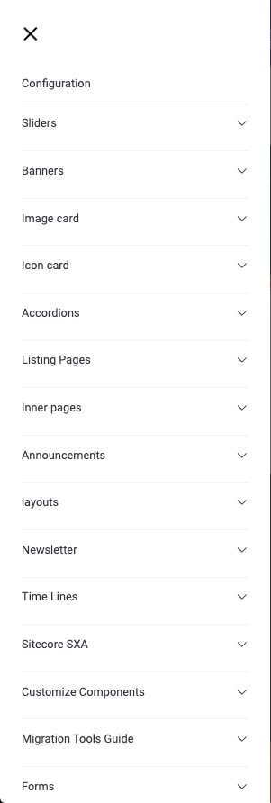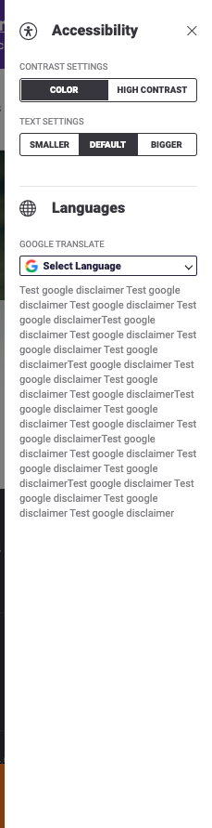

# How to use.

1. The available commands for this project .
   1. Compile : npm run gulp compile -- –path ex-header –extension
   2. Compile & include under ADGE tenant : npm run gulp compile -- –path ex-header –extension –full –dest [ADGEFolder]
   3. Deploy : npm run gulp deploy -- –path ex-header –extension
2. *Now project have full copy from this extension theme under the project theme and you can apply the project brand guideline and configure component based on project ne*

# Component features and configure.

You have access now to configure component with the below item.

$header-navbar-button-width: 85px !default;

$header-navbar-text-color: $grey-900!default;

$header-navbar-background-color: $white-color !default;

$header-navbar-buttons-number : 1 !default;

$header-search-icon-color: $grey-900!default;

$header-search-icon-scrolled-color: $grey-900 !default;

$header-search-icon-background: transparent !default;

$header-search-icon-hover-color: $grey-900!default;

$header-search-icon-scrolled-hover-color: $grey-900 !default;

$header-sidebar-background: $white-color !default;

$header-sidebar-links-color: $grey-900!default;

$header-sidebar-links-hover-color: $primary-color !default;

$header-sidebar-header-color: $grey-900!default;

$header-sidebar-link-border: $grey-100 !default;

$header-sidebar-box-shadow: $grey-900!default;

$header-sidebar-header-background: transparent !default;

$header-overlay-color: $grey-900!default;

$header-small-lang-switch-color: $grey-900!default;

$header-small-lang-switch-hover-color: $primary-color3 !default;

$header-logo-seprator-boder-color: $grey-300 !default;

$header-search-seprator-boder-color: $grey-200 !default;

$header-side-menu-nav-background: transparent !default;

$header-side-menu-nav-color: $grey-900!default;

$header-side-menu-nav-hover-background: $grey-100 !default;

$header-side-menu-nav-hover-color: $grey-900!default;

$header-search-icon-hover-background: $grey-100 !default;

$header-search-box-input-color:$grey-100;

$header-small-lang-switch-background: $primary-color !default;

$header-header-height: 110px !default;

$header-logo-height: 55px !default;

$header-sidemenu-width: 375px !default;

$header-logo-seprator-boder-width: 1px !default;

$header-search-seprator-border-width: 1px !default;

$header-logo-menu-height: 60px !default;

$header-upper-navigation-menu-height: 100% !default;

$header-upper-navigation-menu-font-size: 14px !default;

$header-upper-navigation-menu-font-weight: bold !default;

$header-search-icon-font-size: 25px !default;

$header-icon-height: 100% !default;

$header-icon-width: 85px !default;

$header-icon-small-width: 50px !default;

$header-header-navigation-marker-height: 5px !default;

$header-header-navigation-marker-bg: $primary-color !default;

$header-header-border : 1px solid $grey-200 !default;

$header-lang-switch-ar-font: $font_ar !default;

$header-lang-switch-en-font: $font_en !default;

$header-sidemenu-x-padding : 30px !default;

$header-transition-time:0.3s !default;

$header-scrolled-navbar-text-color:$grey-900 !default;

$header-scrolled-navbar-background-color:$white-color !default;

$header-scrolled-header-height:85px !default;

$header-scrolled-border-color:$white-color!default;

$header-scrolled-logo-menu-height:$header-logo-menu-height !default;

$header-scrolled-logo-height:$header-logo-height !default;

$header-scrolled-lnavbar-text-color:$grey-900 !default;

$header-navbar-buttons-sm-number: 0 !default;

$header-settings-wrp-width: 280px !default;

$header-settings-wrp-bg-color: $white-color !default;

$header-settings-close-btn-size: 14px !default;

$header-settings-label-color: $grey-700 !default;

$header-settings-btn-color : $grey-900 !default;

$header-settings-btn-border : 2px solid $grey-900 !default;

$header-settings-btn-height : 28px !default;

$header-settings-header-color: $grey-900 !default;

$header-settings-close-btn-color : $grey-900!default;

$header-settings-btn-active-bg: $grey-900 !default;

$header-settings-btn-active-color: $white-color !default;

$header-settings-icon-size: 24px !default;

$header-settings-overlay-bg: color-opacity(#000 , 0.5);

# How to configure component.

There are various ways to configure the component:

1. **CSS Class / Data Configuration (on the variant)**

**CSS Class Configuration Method**

These styles can be applied in the variant to get the desired result

|  |  |  |
| --- | --- | --- |
| Feature | Modifier | Default value |
| Center logo | ex-header--centered-logo |  |

1. **Adding Built-In or Bootstrap Class (on the variant)**
   1. Spaces, Font weights, Display, Position properties etc can be added by bootstrap classes
      1. i. Spacing: <https://getbootstrap.com/docs/4.0/utilities/spacing/>
      2. ii. Flex: <https://getbootstrap.com/docs/4.4/utilities/flex/>
      3. iii. Font: <https://getbootstrap.com/docs/4.0/content/typography/>
   2. These classes should only be added to match the design
   3. For built-in classes check 7 Below to see the entire list
2. **SCSS Variable Override (on the _override.scss file)**

To configure the component we can take the above variables from section **4. Component features and configure** and add them to: adge-ph2/themes/<ADGE>/vars/_override.scss, this file with your desired changes to match the design.

1. **Complete style override**
   1. This should be the last and final option if the above 3 didn’t get you the desired output
   2. This is overwriting the SCSS of the component by adding your own style to it
   3. **Note: Take permission before doing this override**
   4. Instructions:
      1. Open the file /adge-ph2/themes/<ADGE>/sass/overrides.scss and add your own SCSS styles to override the faulty component.

# Dependencies

components-header.css

components-side-menu.css

modernizr.min.js

components-side-menu.js

components-burgermenu.js

# Examples

If you need to change navbar button width

$header-navbar-button-width: 85px !default;

If you need to change text color

$header-navbar-text-color: $black-color !default;

If you need to change background color

$header-navbar-background-color: $white-color !default;

If you need to change icon color

$header-search-icon-color: $black-color !default;

If you need to change icon background

$header-search-icon-background: transparent !default;

If you need to change icon hover color

$header-search-icon-hover-color: $black-color !default;

If you need to change sidebar background

$header-sidebar-background: $white-color !default;

If you need to change links color

$header-sidebar-links-color: $black-color !default;

If you need to change links hover color

$header-sidebar-links-hover-color: $primary-color !default;

If you need to change sidebar header color

$header-sidebar-header-color: $black-color !default;

If you need to change sidebar link border

$header-sidebar-link-border: $border-color !default;

If you need to change sidebar header background

$header-sidebar-header-background: transparent !default;

If you need to change overlay color

$header-overlay-color: rgba(0, 0, 0, 0.7) !default;

If you need to change lang switch color

$header-small-lang-switch-color: $white-color !default;

If you need to change logo separator border color

$header-logo-seprator-boder-color: $border-color !default;

If you need to change search separator color

$header-search-seprator-boder-color: $border-color !default;

If you need to change sidemen nav background

$header-side-menu-nav-background: transparent !default;

If you need to change side menu nav color

$header-side-menu-nav-color: $black-color !default;

If you need to change menu nav hover background

$header-side-menu-nav-hover-background: #E7E6EA !default;

If you need to change menu nav hover color

$header-side-menu-nav-hover-color: $black-color !default;

If you need to change search icon hover background

$header-search-icon-hover-background: #E7E6EA !default;

If you need to change search box input color

$header-search-box-input-color:#E7E6EA;

If you need to change lang switch background

$header-small-lang-switch-background: $black-color !default;

If you need to change header height

$header-header-height: 90px !default;

If you need to change logo height

$header-logo-height: 55px !default;

If you need to change sidemen width

$header-sidemenu-width: 375px !default;

If you need to change logo separator border width

$header-logo-seprator-boder-width: 1px !default;

If you need to change search separator border width

$header-search-seprator-border-width: 1px !default;

If you need to change logo menu height

$header-logo-menu-height: 60px !default;

If you need to change upper navigation menu height

$header-upper-navigation-menu-height: 100% !default;

If you need to change upper navigation menu font size

$header-upper-navigation-menu-font-size: 14px !default;

If you need to change upper navigation menu font weight

$header-upper-navigation-menu-font-weight: bold !default;

If you need to change search font size icon

$header-search-icon-font-size: 25px !default;

If you need to change header icon height

$header-icon-height: 100% !default;

If you need to change header icon width

$header-icon-width: 85px !default;

If you need to change header navigation marker height

$header-header-navigation-marker-height: 5px !default;

If you need to change header navigation marker background

$header-header-navigation-marker-bg: $primary-color !default;

If you need to change header border color

$header-header-border-color : #d8d8d8 !default;

If you need to change header lang switcher

$ex-header-lang-switch-ar-font: $font_ar;

$ex-header-lang-switch-en-font: $font_en;

If you need to change sidemen horizontal padding

$header-sidemenu-x-padding : 30px !default;

If you need to change transition time

$ex-header-transition-time:0.3s;

If you need to change scrolled navbar text color

$ex-header-scrolled-navbar-text-color:$white-color;

If you need to change scrolled navbar background color

$ex-header-scrolled-navbar-background-color:#441717;

If you need to change header height

$ex-header-scrolled-header-height:120px;

If you need to change border color

$ex-header-scrolled-border-color:black;

If you need to change height menu

$ex-header-scrolled-logo-menu-height:$header-logo-menu-height;

If you need to change logo height

$ex-header-scrolled-logo-height:$header-logo-height;

If you need to change navbar text color

$ex-header-scrolled-lnavbar-text-color:$white-color;

Examples2:

I need to change the height of the header

$header-height: $header-height-value;

Then will paste the a above variable in project folder theme in file _override.scss and change with any variable based on site needs.

$header-height: 90px